LABORATORY # 07
Characteristics of a Bipolar Junction Transistor

Purpose
Introduce the concept of Bipolar Junction Transistors; one component of a MOSFET is a BJT. Understanding the configuration and states of BJTs will be a critical part of knowing how MOSFETs work to get an in depth understanding of transistors. Both NPN and PNP constructions will be considered. Constants and variables relating to BJTs will be discussed and utilized in the Procedure to confirm full understanding of the material.

Theoretical Background
Construction - A BJT is constructed with three parts: a collector region, a base region and an emitter region. The base is also at times referred to as the channel if the BJT is field affected into allowing current to flow through collector and emitter. For an NPN the base is a P-type material (material with extra holes), the collector and emitter regions are made of an N-type material (material with extra electrons). The emitter region will contain a higher density of electrons than the collector region for this NPN to encourage current to flow from the collector to the emitter. For a PNP the base is an N-type material while the collector and emitter regions are made of a P-type material. The emitter region will contain a higher density of holes than the collector region for this PNP to encourage current to flow from the emitter to the collector. This gives all BJTs a design of two junctions one emitter-base the other collector-base, hence the name.

Operation - The current is meant to flow through the base region if the transistor is in “Forward” or “Reverse-active mode”. Meaning, DC current in the transistor is flowing through the base but only a small amount is coming from or going to the base. “Forward-active mode” means the DC current is flowing in the direction of the base-collector designed junction material and in the opposite direction as the base-emitter designed junction material. “Reverse-active-mode” means the DC current is flowing opposite of the base-collector designed junction material and in the same direction as the base-emitter designed junction material. Always make sure your transistors active-mode is the correct one for what you are trying to do (most often forward-active mode). The DC current will flow in the direction of the designed junction material for both junctions if the operation is “Saturation mode”. The DC current will flow in the opposite direction of the designed junction material for both junctions if the operation is “Cut-off mode”.

Appearance - The way a BJT appears can be clarified on the Data Sheet made by the manufacturer for that specific BJT.

NPN PNP Physical Appearance
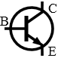
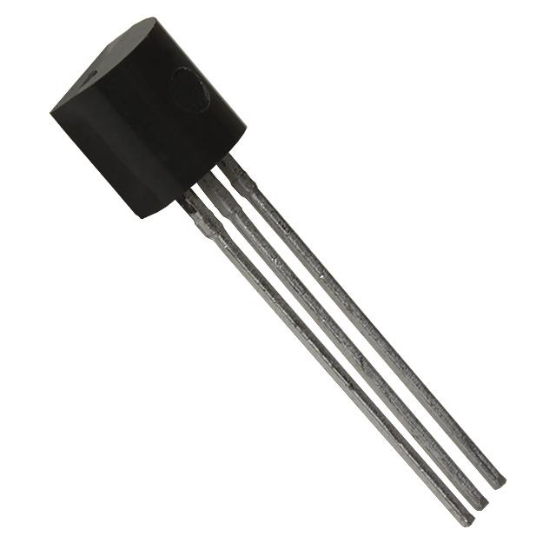
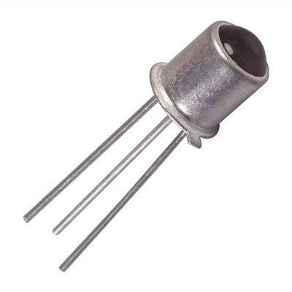
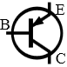

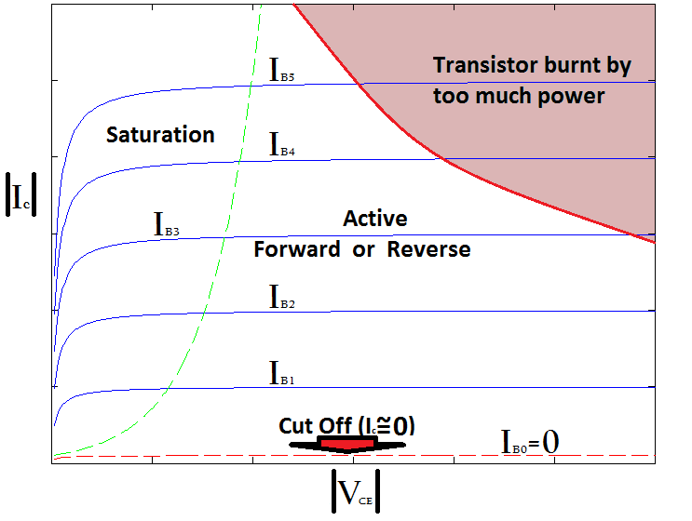
Figure 7.1 Output characteristic of BJT in different region

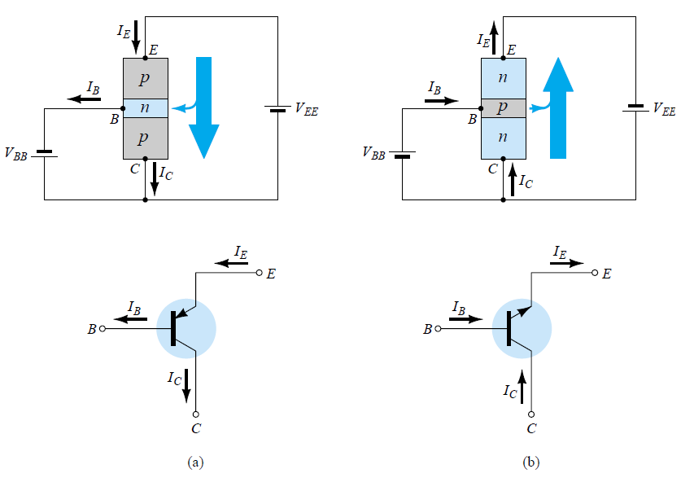
Figure 7.2 Common Collector Configuration* (a) pnp (b) npn
BJT Kirchoff's Voltage Law: 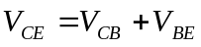
BJT Kirchoff's Current Law: 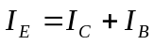
Common Emitter Configuration: 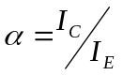, 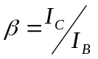, 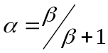 and 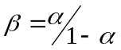
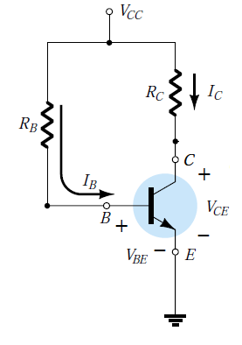
Figure 7.3 Common Collector Circuit*

Use R_{B} = 10KΩ, 50KΩ, 100KΩ, 150KΩ, 200KΩ and 300KΩ, R_{C}=1KΩ, V_{CC}=16V. Find the values of I_{B}, I_{C}, I_{E} and V_{CE} for each R_{B}.
Output Characteristics Results:
Table 7.1
 | Multisim Results |  |  |  | Experimental Results
R_{B} | I_{B} (uA) | I_{C} (mA) | I_{E} (mA) | V_{CE} (V) | I_{B} (mA) | I_{C} (mA) | I_{E} (mA) | V_{CE} (V)
10KΩ | 1.529 | 15.903 | 17.432 | 0.097 | 1.538 | 16.338 | 17.876 | 0.0667
50KΩ | 0.307 | 15.841 | 16.148 | 0.159 | 0.307 | 16.266 | 16.573 | 0.1467
100KΩ | 0.153 | 12.544 | 12.697 | 3.456 | 0.153 | 16.221 | 16.374 | 0.2326
300KΩ | 0.051 | 4.457 | 4.508 | 11.543 | 0.044 | 10.783 | 10.827 | 7.983
500KΩ | 0.031 | 2.6 | 2.631 | 13.4 | 0.031 | 7.832 | 7.863 | 11.158
1MΩ | 0.015 | 1.21 | 1.225 | 14.79 | 0.015 | 4.013 | 4.028 | 13.654
2MΩ | 0.008 | 0.551 | 0.559 | 15.449 | 0.008 | 2.011 | 2.019 | 14.913
3MΩ | 0.005 | 0.345 | 0.350 | 15.655 | 0.004 | 1.325 | 1.329 | 15.324
Procedure:
- Perform analytical calculations as discussed in lab. Determine the followings: I_{B}, I_{C}, I_{E}, V_{CE}. Use NPN type BJT (2N3903/MPSA42). See the value of β using data sheet.
- Build the circuit as shown in Fig. 7.3 in Multisim and calculate all parameters as discussed in step 1.
- Draw the output characteristic curve as shown in Fig. 7.1 using Multisim results.
- Build the circuit as shown in Fig. 7.3 in Lab and calculate all parameters as discussed in step 1.
- Draw the output characteristic curve as shown in Fig. 7.1 using Experimental results.
- Identify I_{c, saturation} along y-axis and V_{CC} along x-axis. Evaluate the Q-point behavior of given npn transistor. (Hint: Q-point is dependent on I_{B}, I_{C} and V_{CC}).
- Discuss your results in conclusion section. Comment Q-point behavior with respect to I_{B}, I_{C} and V_{CC.}
One exemplary circuit is shown below for your reference.

